**Student Name - Nilesh Bhandari**

**Student ID - 36495893**

**Course - MS Marketing**

**Instructor - Prof. Nicolas Alexander**

**Module - MKTG511**

**Strategic Evaluation of Burberry and Boohoo International Expansion Opportunities**

**Summary**

British luxury apparel house Burberry is famous for its trench coats and check pattern. Established in 1856, it sells high-end accessories, outerwear, and ready-to-wear through 490 retail locations, franchises, and wholesale distribution worldwide. Burberry earned approximately £2.6 billion in 2022 from Asia Pacific, Europe, and the Americas, thanks to its strong online presence and physical retail.

Burberry should expand flagship locations that showcase the brand experience, organic expansion of directly-operated retail outlets, and dedicated e-commerce capabilities to drive future growth. The quickly changing Indian luxury market is a strategic focus, using regional products and marketing to attract young, aspirational consumers. Maintaining brand distinctiveness while adapting to multiple cultures is crucial.

Boohoo, a disruptive online fast-fashion company, sells stylish, affordable clothes. Its digital platforms offer 18 million clients in 200 countries, with brands like PrettyLittleThing and Nasty Gal, earning £1.9 billion in 2022. Boohoo's e-commerce business can benefit from strategic acquisitions, dedicated online distribution facilities in target regions like the US, and local joint ventures despite fierce competition. To reach varied consumer categories, localizing through data-driven insights and influencer marketing is essential.

Burberry is anchored in British luxury, while Boohoo is a digital fast-fashion brand. In the evolving global fashion sector, their positioning, operational models, target consumers, and value propositions require different international expansion strategies.



**A. Firm brands:**

Burberry, famous for its tartan pattern and equestrian roots, is its major brand. Also under the Thomas Burberry monogram and Burberry Beauty cosmetics and fragrances.

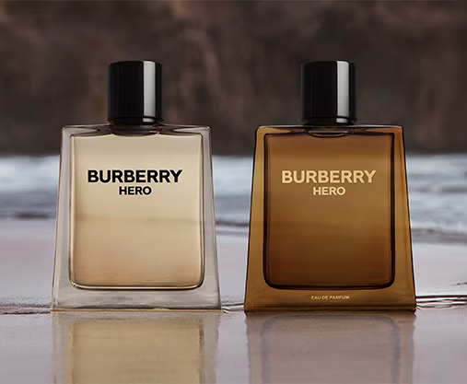

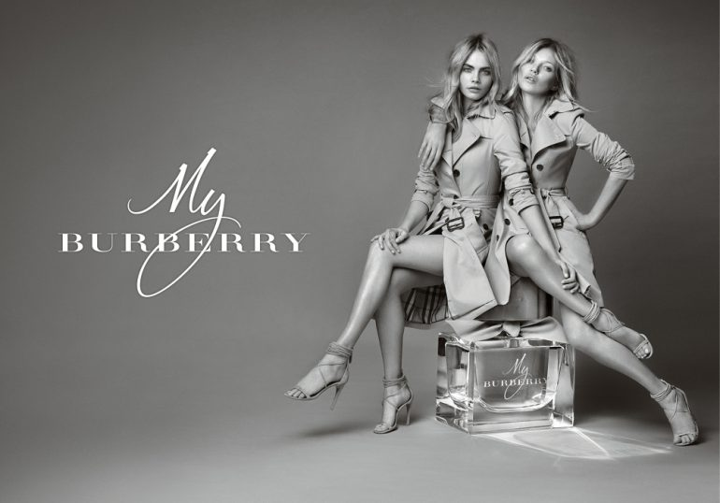

**B. Franchising, offline/online operations:**

Burberry has franchises, direct storefronts, and wholesale distribution channels. The 2022 annual report listed 490 retail shops in 35 countries, including 144 franchised stores (Burberry, 2022). Online sales make up a large part of Burberry's revenue.

**C. Firm's markets:**

Burberry is a luxury brand sold internationally. Burberry's 2022 annual report lists Asia Pacific (Mainland China), EMEIA (Europe, Middle East, India, and Africa), and the Americas as its primary markets.

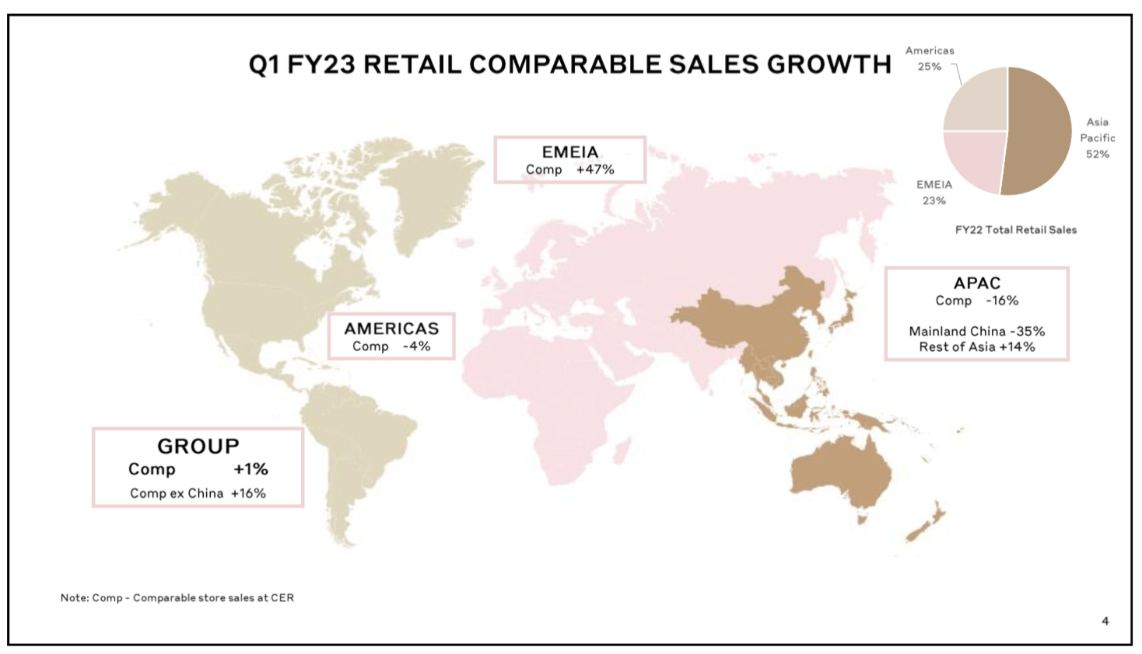

To evaluate the opportunities and challenges for Burberry operating in France, India, and the US, I will analyze each market under the following headings:

**France:**

**1. Regulatory environment:**

* France imposes hefty import charges and taxes on luxury products (Deloitte, 2022). This may affect Burberry's pricing and profitability.

**2. Economic conditions:**

* France has a strong economy and a large luxury goods market (Statista, 2023). Recent economic development has been slow, which may affect luxury spending (World Bank, 2023).

**3. Social conditions:**

* Burberry might target France's sizable and prosperous middle class (Reuters, 2021). Sustainability and ethical consumerism are also becoming more popular, which may affect customer preferences (Deloitte, 2022).

**4. Cultural conditions: consumer and organizational**

* Burberry's brand positioning matches French consumers' love of luxury and high-quality items (Deloitte, 2022). However, the corporation may need to tailor its marketing and products to French tastes.

**5. Retail competitive structure:**

* French luxury retailers compete with established local and worldwide brands (Deloitte, 2022). Burberry must differentiate and preserve its brand identity to succeed in this market.

**India:**

**1. Regulatory environment:**

* Burberry faces hurdles in India due to stringent luxury import restrictions and tariffs (Deloitte, 2022). However, the government is encouraging foreign retail investment (IBEF, 2023).

**2. Economic conditions:**

* Luxury brands may capitalize on India's fast-growing economy and developing middle class with disposable income (World Bank, 2023). Income inequality and regional discrepancies may hinder market size (IBEF, 2023).

**3. Social conditions:**

* Young, aspirational Indians are increasingly interested in luxury brands as status symbols (Deloitte, 2022). Value and cultural values are also stressed (IBEF, 2023).

**4. Cultural conditions: consumer and organizational**

* Burberry may need to adjust its products and marketing to suit Indian tastes and customs (Deloitte, 2022). Additionally, the corporation may need to manage cultural variances in organizational procedures.

**5. Competition in retail:**

* Local and international luxury companies compete in India's underdeveloped but developing luxury retail sector (IBEF, 2023). Burberry may compete with local and international luxury brands.

**United States:**

**1. Regulatory environment:**

* With lower import fees and taxes than other markets, the US is business-friendly for luxury goods (Deloitte, 2022).

**2. Economic conditions:**

* There are many wealthy consumers in the US due to its strong economy and high disposable incomes (World Bank, 2023). Economic conditions vary by area and consumer group.

**3. Social conditions:**

* Various demographic groups in the US have various preferences and purchasing power (Deloitte, 2022). US customers are also becoming more socially and environmentally sensitive (Statista, 2023).

**4. Cultural conditions: consumer and organizational**

* Luxury brands are popular in America because consumers value quality, status, and exclusivity (Deloitte, 2022). However, US consumers have various cultural preferences, thus Burberry may need to adjust its marketing and product offers.

**5.** **Retail competitive structure**:

* Established domestic and foreign brands compete in the US luxury retail sector (Deloitte, 2022). Burberry must differentiate and preserve its brand identity to succeed in this market.

Assessing Burberry's market entry options based on its current operations and strategies. We must assess Burberry's current operations, future growth ambitions, and business model and goals to determine the best market entry methods.

**1. Flagship stores: company-owned, large in scale to showcase the brand:**

Burberry has flagship locations in London, Paris, and New York to display its brand and offer a premium retail experience (Burberry, 2022). Burberry should continue to use this successful market entry and brand positioning strategy.

**2. Organic growth: new store development within the existing or an integrated organizational framework:**

Burberry is extending its directly-operated shop network in existing and new areas to achieve organic growth (Burberry, 2022). This strategy lets Burberry control its brand experience and retail operations and should be a focus for its expansion.

**3. Acquisition: the acquisition of control over a firm or brand in the international market:**

Burberry has not aggressively pursued acquisitions in recent years, but this could be a strategy for entering new markets or improving its position in existing markets. However, purchases should be carefully assessed to ensure brand and value alignment with Burberry.

**4. Joint ventures: between a firm in the host country and an international entrant or between two firms that enter into a joint venture agreement in order to enter the host market:**

Burberry could use local partners' experience and resources to explore new markets or product categories through joint ventures. However, Burberry should carefully assess possible partners and retain brand and quality control.

**5. Franchising: a business arrangement between a franchisor and an international franchisee, using the franchisor's retail format and brands:**

Burberry has franchised many of its outlets, which has been successful (Burberry, 2022). This strategy leverages local experience and brand consistency to rapidly expand and penetrate markets.

**6. Online: dedicated online distribution facilities in the host market:**

Burberry has invested in digital capabilities, including specific e-commerce platforms in multiple areas (Burberry, 2022). This strategy should continue for Burberry as internet retail and omnichannel experiences grow more essential in luxury.

Based on Burberry's current operations and strategies, **the three most appropriate market entry methods are:**

**1. Flagship stores**

**2. Organic growth (directly-operated stores)**

**3. Online (dedicated e-commerce platforms)**

These strategies support Burberry's goal of brand control, shop expansion, and digital transformation (Burberry, 2022). Acquisitions and joint ventures should be carefully considered, but franchising may complement it in some sectors.

Based on Burberry's examination of France, India, and the US markets, I advocate expanding in India. This justifies it:

**(a) Recommended expansion market: India**

**1. Economic conditions:** Burberry has huge prospects in India due to its fast-growing economy and burgeoning middle class with discretionary income (World Bank, 2023; IBEF, 2023).

**2. Social conditions:** Young, aspirational Indians are increasingly interested in luxury brands as status symbols (Deloitte, 2022).

**3. Cultural conditions:** India has various tastes and traditions, but the luxury industry is still underdeveloped, giving Burberry an opportunity to build a strong presence and adapt its offerings to the local market (Deloitte, 2022; IBEF, 2023).

**4. Retail competitive structure:** India's luxury retail sector is developing but less competitive than France and the US, giving Burberry an opportunity to grow (IBEF, 2023).

**(b) Developing operations in the Indian market:**

**1. Flagship stores:** Open Burberry flagship stores in Mumbai, Delhi, and Bangalore to give Indian customers a premium shopping experience.

**2. Organic growth:** Leveraging urban luxury goods demand, expand directly-operated stores in tier-1 and tier-2 cities.

**3. Franchising:** Use local franchisees' market experience to swiftly extend the brand in smaller cities and villages.

**4. Online presence:** Meet the growing demand for online luxury shopping with an Indian-specific e-commerce platform and digital marketing methods.

**5. Cultural adaptation:** While keeping the brand's values and identity, adjust products, marketing campaigns, and shop experiences to Indian cultural tastes and traditions.

**6. Localization:** Work with local designers and craftspeople to produce distinct collections or product lines for Indian consumers to foster cultural connection and exclusivity.

**7. Brand ambassadors:** Work with Indian celebrities, influencers, and significant figures to raise brand recognition and appeal to aspirational Indian consumers.

Burberry can capitalize on the growing demand for luxury goods in the rapidly evolving Indian market by focusing on the Indian market and implementing a well-coordinated strategy that includes flagship stores, organic growth, franchising, online presence, cultural adaptation, localization, and strategic brand partnerships.

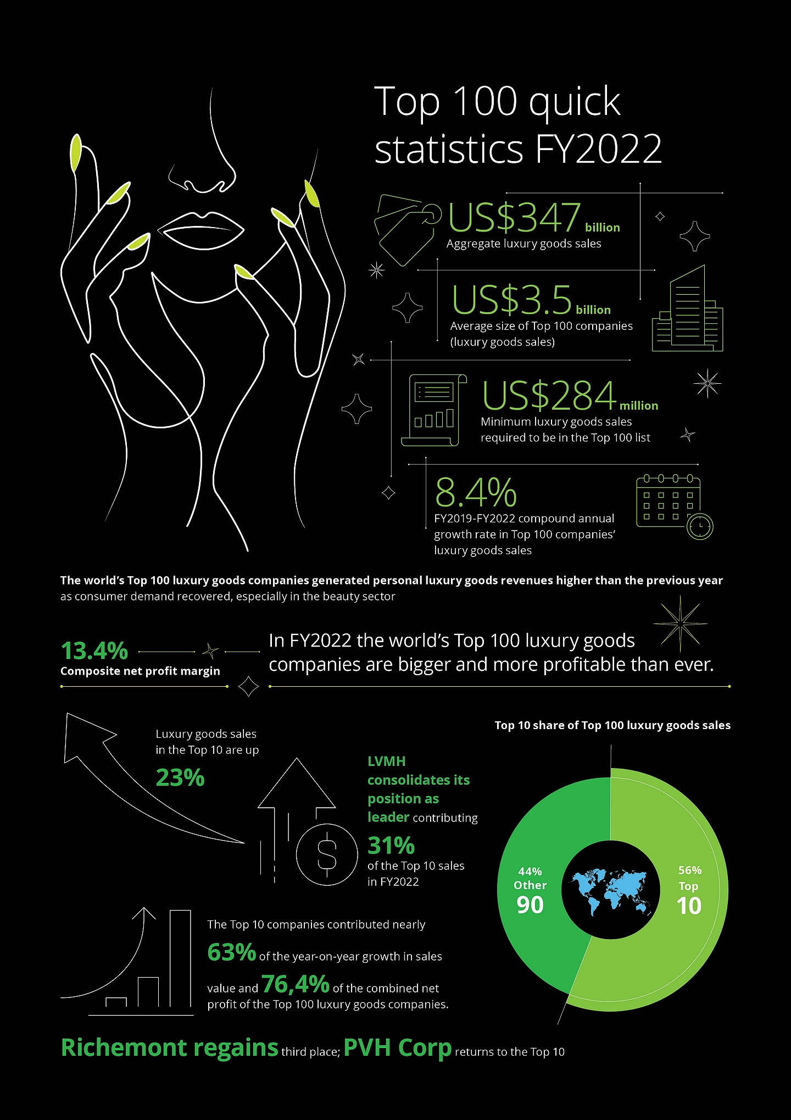



**A. Brands used by the firm:**

Boohoo Group (2023) includes Boohoo, BoohooMAN, PrettyLittleThing, Nastygal, Karen Millen, Coast, Oasis, Warehouse, and Debenhams.

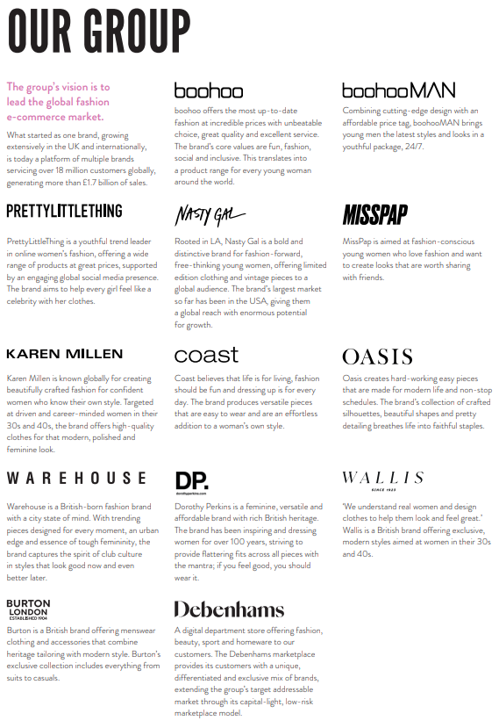

**B. Operating characteristics: offline/online, franchising, etc.:**

Online apparel company Boohoo focuses on e-commerce and digital marketing (Boohoo Group, 2023). The company conducts business online and does not franchise.

**C. Markets in which the firm operates:**

Boohoo operates worldwide. Their website states that they serve customers in practically every country in Europe, the Americas, Australia, Asia, and the Middle East (Boohoo Group, 2023).

We will consider the following factors to assess Boohoo's potential and problems in France, India, and the US:

**France:**

**1. Regulatory environment:**

* E-commerce and internet shopping in France are regulated by strict consumer protection legislation (European Commission, 2022).
* GDPR and other data privacy rules must be followed (European Union, 2018).

**2. Economic conditions:**

* France has a huge consumer market and stable economy (World Bank, 2022a).
* Consumer confidence and spending power may be affected by economic volatility.

**3. Social conditions:**

* Online shopping is rising in France, especially among young people (Kantar, 2021).
* Consumer tastes may be influenced by fashion industry ethics and sustainability.

**4. Cultural conditions:**

* French fashion buyers respect quality, style, and brand reputation (Deveaux, 2020).
* Localization and adaption to French sensibilities may be needed.
* French business and labor rules may require Boohoo to change its culture.

**5. Retail competitive structure:**

* French fashion retail is competitive with well-established local and international businesses (Euromonitor, 2022a).
* Retailers like Amazon and Zalando compete online.

**India:**

**1. Regulatory environment:**

* E-commerce and retail foreign direct investment in India are regulated by complex laws (Government of India, 2022).
* Consider data localization and privacy laws (Basu, 2022).

**2. Economic conditions:**

* India's economy is developing and its customer base is getting richer (World Bank, 2022b).
* Income inequality and regional inequalities may affect consumer spending.

**3. Social conditions:**

* E-commerce and internet shopping are growing, especially in cities (IBEF, 2022).
* Cultural norms may impact fashion choices.

**4. Cultural conditions:**

* Regional, religious, and cultural factors may influence Indian consumer preferences (Sinha & Sheth, 2018).
* Localization and adaption to local tastes are essential.
* Boohoo may need to adjust their culture to suit Indian business and society.

**5. Retail competitive structure:**

* Indian fashion retail is competitive with well-established local and foreign businesses (Euromonitor, 2022b).
* Online rivalry from Amazon and Flipkart.

**United States:**

**1. Regulatory environment:**

* E-commerce and consumer protection rules are well-established in the US (Federal Trade Commission, 2022).
* Some states have tougher data privacy rules (IAPP, 2023).

**2. Economic conditions:**

* The US consumer market is mature and economically stable (World Bank, 2022c).
* Consumer confidence and spending power may be altered by economic cycles.

**3. Social conditions:**

* US consumers use e-commerce extensively (Statista, 2023).
* Consumer tastes may be influenced by fashion industry ethics and sustainability.

**4. Cultural conditions:**

* Based on age, ethnicity, and region, American customers may have different tastes (Sojka & Tansuhaj, 1995).
* Brand recognition and value perception matter.
* Boohoo may need to change its culture to match American business and workplace norms.

**5. Retail competitive structure:**

* Established local and multinational firms compete in the US fashion retail sector (Euromonitor, 2022c).
* Amazon and other internet merchants compete with fashion stores.

To determine Boohoo's best market entry techniques, we must assess the company's existing operations, future growth ambitions, and each method's fit in their business model and goals.

Based on the above analysis, the **three most appropriate market entry methods for Boohoo could be:**

**1. Flagship stores:** Flagship stores can highlight the brand and offer a physical presence, but they may not fit Boohoo's online-first and fast-fashion approach. Large flagship store prices may also be a hurdle.

**2. Organic growth:** Given its focus on e-commerce and digital channels, Boohoo may not prioritize organic growth through internal expansion and new shop development inside the present organizational framework.

**3. Acquisition:** Acquisitions can help Boohoo fast grow its brand portfolio, consumer base, and market share. The business bought PrettyLittleThing, Nasty Gal, and Debenhams (Boohoo Group, 2021). Boohoo may acquire to enter new markets or strengthen its presence in existing ones.

**4. Joint ventures:** Boohoo could enter a new market using a local partner's knowledge and resources. Boohoo's business strategy relies primarily on its own e-commerce platforms and digital marketing tactics, thus this approach may not work.

**5. Franchising:** Since Boohoo operates mostly online and has few physical stores, franchising may not be a good entrance method.

**6. Online:** Boohoo may benefit from dedicated online distribution in host markets. Local e-commerce, warehousing, and logistics in key markets would fit Boohoo's business model and improve delivery and customer service.

The aforementioned study suggests **three market entry methods for Boohoo**:

**1. Acquisitions:** To aggressively increase its brand portfolio and market reach through strategic acquisitions.

**2. Online:** To build online distribution, e-commerce, and logistics platforms in target areas.

**3. Joint ventures:** To explore joint ventures with local partners in select markets that fit Boohoo's e-commerce strategy and provide relevant resources or experience.

Consider that Boohoo has grown mostly through online channels and digital marketing to explain these selections. Despite acquiring multiple brands, the company focuses on e-commerce and rapid fashion. Thus, acquisitions and online expansion may be better for Boohoo's future growth and worldwide expansion.

Based on legislative, economic, social, cultural, and competitive aspects in France, India, and the US markets, Boohoo should expand in the US. Reasoning:

**(a) Recommended market for future expansion: United States**

The US market offers Boohoo various advantages for growth:

**1. Established regulatory environment:** Boohoo's online activities are steady and familiar in the US because of its well-defined e-commerce and consumer protection laws (Federal Trade Commission, 2022).

**2. Mature consumer market:** The US has a huge, steady consumer market that uses internet purchasing and e-commerce (Statista, 2023; World Bank, 2022).

**3. Cultural alignment:** Americans like fast-fashion and brand familiarity, which matches Boohoo's value promise (Sojka & Tansuhaj, 1995).

**4. Competitive landscape**: Boohoo's online-focused business and reasonable pricing may provide them an edge in the extremely competitive US apparel retail sector (Euromonitor, 2022).

**(b) Recommended approach to developing operations in the US market:**

**1. Online expansion:** Create US-based online distribution facilities, e-commerce platforms, and logistical capabilities to improve delivery and the customer experience (Boohoo Group, 2021).

**2. Localization and marketing:** Use data-driven insights and localised digital marketing efforts to tailor products, marketing methods, and online platforms to American tastes and customs.

**3. Strategic acquisitions:** Buy US fashion brands or e-commerce companies to quickly grow market share, client base, and brand recognition (Boohoo Group, 2021).

**4. Partnerships and collaborations:** Work with fashion influencers, celebrities, and stores to boost brand awareness and appeal to target audiences.

**5. Sustainability and ethical practices:** As American customers value sustainability and ethics in fashion, highlight Boohoo's dedication to them (Deveaux, 2020).

Boohoo can profit on this mature and responsive market by focusing on the US market and leveraging its online strengths, localization initiatives, potential acquisitions, and collaborations.

**Conclusion**

Burberry and Boohoo confront different problems and opportunities in different areas when expanding globally. Boohoo's online-focused, fast-fashion model requires a different market entry strategy than Burberry's legacy and luxury positioning.

Burberry may expand in India, according to the analysis. India is a strong chance for Burberry to expand due to its fast-growing economy, wealthy middle class, and rising luxury goods demand. Burberry can appeal to the aspirational Indian consumer and adapt to local cultural tastes by using flagship stores, organic development through directly-operated locations, franchising, and a strong online presence. Success in this industry requires managing regulatory hurdles, income gaps, and different consumer preferences.

However, Boohoo's online-focused business model and cheap prices make the US an attractive expansion target. Boohoo benefits in the US market from its mature consumer market, well-established regulatory environment, and cultural compatibility with fast-fashion trends. Boohoo can capitalize on this competitive but receptive market by focusing on internet expansion, strategic acquisitions, and regional marketing.

Both organizations must carefully assess and adjust their market entry tactics to match their target markets' distinctive traits. Burberry's focus on brand exclusivity and premium retail experiences may necessitate a more methodical approach, while Boohoo's agility and digital skills may allow for faster growth through online channels and strategic acquisitions.

Burberry and Boohoo must grasp local customer preferences, regulatory frameworks, and competitive dynamics to succeed in global expansion, regardless of location or entry strategy. These brands can navigate international marketplaces and seize growth possibilities by using their strengths, adapting to cultural differences, and adopting innovative strategies.

**References**

Boohoo Group. (2023). About Us. Retrieved from https://www.boohoo.com/about-us

Boohoo Group. (2021, May 5). Boohoo Group plc acquisition of the remaining minority interest in PrettyLittleThing.com Limited.

Burberry. (2022). Annual Report 2021/22. <https://www.burberryplc.com/en/investors/annual-report.html>

Basu, N. (2022, November 28). Data localization in India: Overview and impact on businesses. Mondaq.

<https://www.mondaq.com/india/data-protection/1256658/data-localization-in-india-overview-and-impact-on-businesses>

Boohoo Group. (2021, May 5). Boohoo Group plc acquisition of the remaining minority interest in PrettyLittleThing.com Limited.

Deloitte. (2022). Global Powers of Luxury Goods 2022. https://www2.deloitte.com/global/en/pages/consumer-business/articles/gx-cb-global-powers-of-luxury-goods.html

Deloitte. (2022). Global Powers of Luxury Goods 2022. https://www2.deloitte.com/global/en/pages/consumer-business/articles/gx-cb-global-powers-of-luxury-goods.html

Deveaux, C. (2020, January 20). French consumer trends in 2020. Gartner. <https://www.gartner.com/en/marketing/insights/daily-insights/french-consumer-trends-2020>

Euromonitor. (2022). Apparel and footwear in the USA. <https://www.euromonitor.com/apparel-and-footwear-in-the-usa/report>

European Commission. (2022, March 22). Consumer protection. <https://ec.europa.eu/info/policies/consumers/consumer-protection_en>

Euromonitor. (2022a). Apparel and footwear in France. https://www.euromonitor.com/apparel-and-footwear-in-france/report

Euromonitor. (2022b). Apparel and footwear in India. https://www.euromonitor.com/apparel-and-footwear-in-india/report

Euromonitor. (2022c). Apparel and footwear in the USA. https://www.euromonitor.com/apparel-and-footwear-in-the-usa/report

European Union. (2018, May 25). General Data Protection Regulation (GDPR). https://gdpr.eu/

Federal Trade Commission. (2022, November 22). E-commerce and the law. https://www.ftc.gov/tips-advice/business-center/guidance/e-commerce-law

Federal Trade Commission. (2022, November 22). E-commerce and the law. https://www.ftc.gov/tips-advice/business-center/guidance/e-commerce-law

Government of India. (2022, June 23). E-commerce rules, 2022. https://consumer.gov.in/sites/default/files/egazette.pdf

IAPP. (2023, April 13). U.S. state privacy legislation tracker. https://iapp.org/resources/article/state-privacy-legislation-tracker/

IBEF. (2023). Luxury Market in India. https://www.ibef.org/industry/indian-luxury-market.aspx

IBEF. (2022, December 22). E-commerce industry in India. <https://www.ibef.org/industry/ecommerce.aspx>

IBEF. (2023). Luxury Market in India. https://www.ibef.org/industry/indian-luxury-market.aspx

Kantar. (2021, June 17). An overview of French e-commerce in 2021. <https://www.kantar.com/inspiration/technology/an-overview-of-french-e-commerce-in-2021>

Reuters. (2021). France luxury groups to court $600 bln premium product growth in China, younger shoppers. https://www.reuters.com/world/china/france-luxury-groups-court-600-bln-premium-product-growth-china-younger-shoppers-2021-11-23/

Sojka, J. Z., & Tansuhaj, P. S. (1995). Cross-cultural consumer research: A twenty-year review. ACR North American Advances, 22, 461-474.

Statista. (2023, March 24). E-commerce in the United States - statistics & facts. <https://www.statista.com/topics/2443/e-commerce-in-the-united-states/>

Sinha, I., & Sheth, J. (2018). Outshoring in India: Studies of corporate cultures. Emerald Publishing.

Sojka, J. Z., & Tansuhaj, P. S. (1995). Cross-cultural consumer research: A twenty-year review. ACR North American Advances, 22, 461-474. https://www.acrwebsite.org/volumes/7734/volumes/v22/NA-22

Statista. (2023, March 24). E-commerce in the United States - statistics & facts. https://www.statista.com/topics/2443/e-commerce-in-the-united-states/

Statista. (2023). Luxury goods industry in France. https://www.statista.com/topics/8894/luxury-goods-industry-in-france/

Statista. (2023). Luxury goods industry in the United States. https://www.statista.com/topics/1156/luxury-goods-industry-in-the-united-states/

World Bank. (2022). United States economic outlook. <https://www.worldbank.org/en/country/unitedstates/overview>

World Bank. (2022a). France economic outlook. https://www.worldbank.org/en/country/france/overview

World Bank. (2022b). India economic outlook. https://www.worldbank.org/en/country/india/overview

World Bank. (2022c). United States economic outlook. https://www.worldbank.org/en/country/unitedstates/overview

World Bank. (2023). GDP growth (annual %) - India. https://data.worldbank.org/indicator/NY.GDP.MKTP.KD.ZG?locations=IN

World Bank. (2023). GDP growth (annual %) - France, India, United States. https://data.worldbank.org/indicator/NY.GDP.MKTP.KD.ZG?locations=FR-IN-US

**Appendix**

